Building Resume Rank: An AI-Based Resume Screening System:
When I started this project, I wanted to work on something that actually solves a problem people deal with every day, not just another dataset-and-model exercise. Resume screening seemed like a good fit. Anyone who has been part of a hiring process, even informally, knows how repetitive and time-consuming it is to go through dozens or hundreds of resumes for a single opening. That's where the idea for Resume Rank came from.
Resume Rank is a resume screening application built with Python and Flask that uses Natural Language Processing to compare candidate resumes against a job description and rank them automatically. It's not meant to replace a recruiter's judgment. It's meant to cut down the amount of time spent on the first pass, so the people making hiring decisions can focus on the candidates who are actually worth their attention.
The Problem I Was Trying to Solve:
Manual resume screening has a few issues that are hard to avoid even with an experienced HR team. Every resume is formatted differently. One candidate lists skills at the top, another buries them inside their work experience section. Terminology varies too — someone might write "REST API development" while another writes "building RESTful services," even though they're describing the same thing.
On top of that, there's the fatigue factor. A recruiter reading resume number 4 in the morning is paying closer attention than they are reading resume number 80 late in the afternoon. That's not a criticism of recruiters, it's just human nature. But it means two equally qualified candidates can end up being judged inconsistently depending on when their resume gets picked up.
I wanted to build something that would apply the same evaluation criteria to every resume in a batch, consistently, and hand the recruiter a ranked shortlist instead of a stack of unsorted PDFs and Word files.
How the System Works:
The application is split into two parts that had to work together: the matching engine that does the actual analysis, and the web interface that recruiters would use.
Uploading resumes and the job description:
The starting point is a simple form. The recruiter pastes the job description into a text box, listing the required skills, responsibilities, and experience level, and then uploads multiple .docx resumes at once. I added a small JavaScript component that shows the selected files with their names and sizes before submission, mainly because I didn't want people uploading files blind and hoping for the best.
Cleaning and preparing the text:
Once the resumes come in, they're converted from .docx into plain text and run through a standard preprocessing pipeline: tokenization, stopwords removal, and stemming/lemmatization. This step doesn't sound like much, but it matters a lot in practice. Without it, words like "developed," "developing," and "development" get treated as completely unrelated terms, which throws off any kind of matching later on.
Scoring each candidate:
This is the part I spent the most time on. I didn't want to rely on a single, crude keyword count, because that approach tends to reward resumes that happen to repeat the right words rather than resumes that actually describe relevant experience. So the system calculates two separate scores:
- A TF-IDF score, which measures how closely the terms in the resume match the terms in the job description, weighted by how distinctive those terms are.
- A semantic/keyword score, which looks at how well the candidate's overall skill set and experience align with what the job is asking for, beyond just literal word overlap.
These two scores get combined into a final match percentage. Based on that number, the system automatically classifies each candidate:
- 70% and above — Shortlisted
- 50% to 69% — Under Review
- Below 50% — Rejected
That threshold system was a deliberate choice. It gives recruiters an immediate sense of where to focus without forcing them to interpret raw percentages on their own.
The Technical Side:
Backend:
The backend runs on Flask, which I chose because it's lightweight and doesn't get in the way when you're trying to connect a processing pipeline to a web interface quickly. Resume data is stored in a SQLite database rather than kept in memory, which was an important decision — I wanted rankings to persist between sessions and I wanted the system to handle bulk uploads without losing data if the server restarted or the page got refreshed.
Each candidate record in the database holds the filename, extracted name, contact details, the raw resume text, the cleaned version used for matching, the individual TF-IDF and semantic scores, the combined score, the current status, and a timestamp. The backend also supports searching and filtering by name, email, score, or status, and lets a recruiter manually override a candidate's status after reviewing them, since the automated classification is a starting point, not a final answer.
Frontend:
There are three main pages:
The screening page is where a recruiter enters the job description and uploads resumes. I kept it deliberately simple with two clear steps, because the people using this tool aren't going to want to learn a new system just to screen a batch of resumes.
The dashboard shows the results once processing is done — total candidates screened, how many were shortlisted, how many are under review, and the top score in the batch, followed by a full ranking table with each candidate's scores and status.
The candidate detail page breaks down an individual candidate's scores, shows a short automated assessment ("Strong Candidate," "Potential Candidate," or "Low Match"), and displays the full extracted resume text. I added this page specifically because I don't think a score alone should ever be the final word — recruiters need to be able to read the actual resume if they want to.
Problems I Ran Into:
The hardest part, by a fair margin, was dealing with how inconsistent resume formatting is in practice. The dataset I worked with covered Full Stack Developers, Business Analysts, Project Managers, and Software Engineers, and no two resumes structured their information the same way. Getting extraction to work reasonably well across that variety took several rounds of adjustment rather than one clean solution.
Deciding how to weight TF-IDF against semantic matching was another thing I went back and forth on. Pure keyword matching is fast and easy to explain, but it misses cases where a resume describes the right experience using different wording than the job description. Relying only on semantic matching, on the other hand, made results harder to justify and occasionally felt inconsistent. Combining both turned out to give more reliable and more explainable rankings than either one on its own.
I also had to keep reminding myself not to over-engineer the interface. It would have been easy to expose every internal score and setting to the user, but the people who'd actually use something like this aren't data scientists. Every screen went through the same filter: would someone in HR with no background in NLP understand this in a few seconds.
What This Project Taught Me:
The biggest thing I took away from this is that a good model isn't worth much if it's wrapped in an interface nobody can use. I spent as much time thinking about database structure, page layout, and how information gets presented as I did on the actual scoring logic, and both mattered.
I also got a much clearer sense of how much preprocessing affects final results. Small inconsistencies in how text gets cleaned can quietly throw off similarity scores in ways that are genuinely hard to trace back later.
Where This Could Go Next:
There's more that could be added if I keep working on this:
- Support for PDF resumes in addition to DOCX
- A feedback loop where recruiter decisions (hired or rejected) get used to improve matching accuracy over time
- Exporting ranked candidate lists to Excel or PDF for offline use
- Support for non-English resumes
- Replacing the statistical semantic matching with embedding-based models for better conceptual matching
Sreenshots:
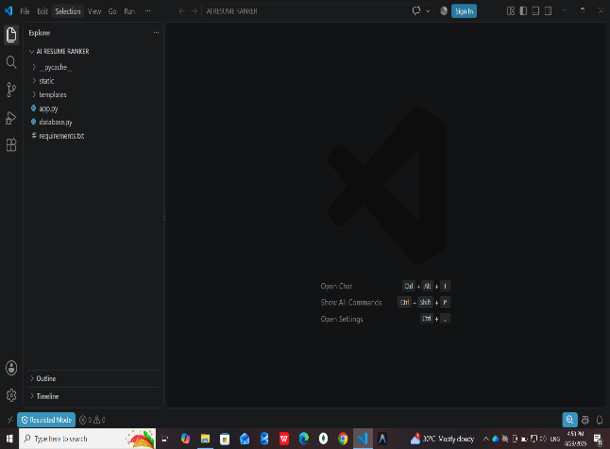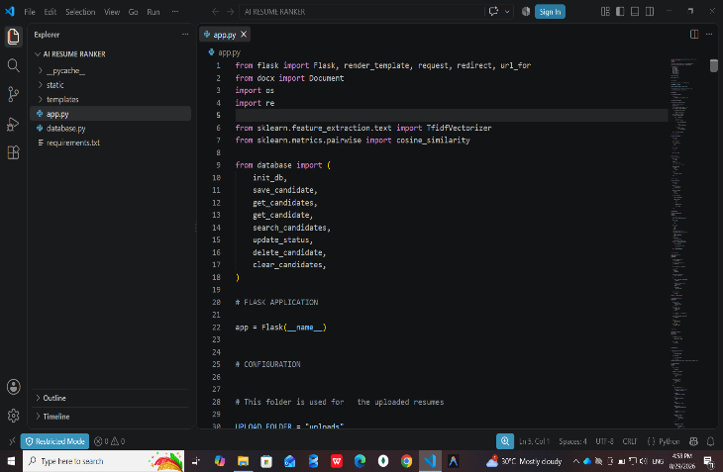

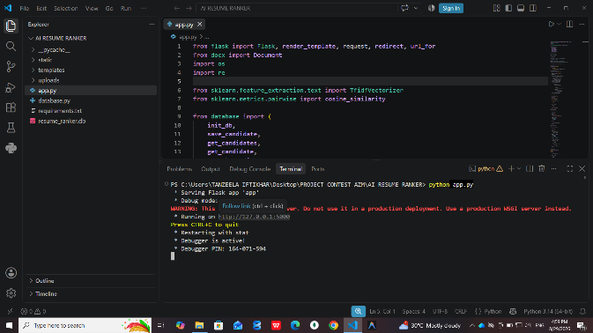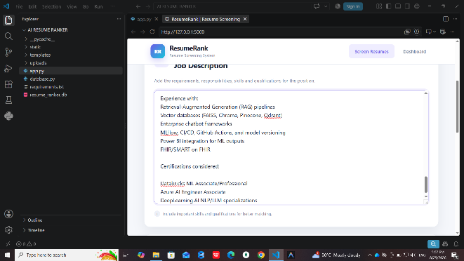

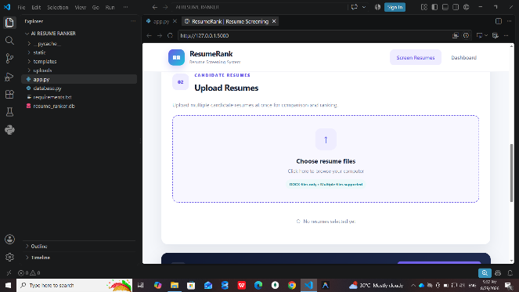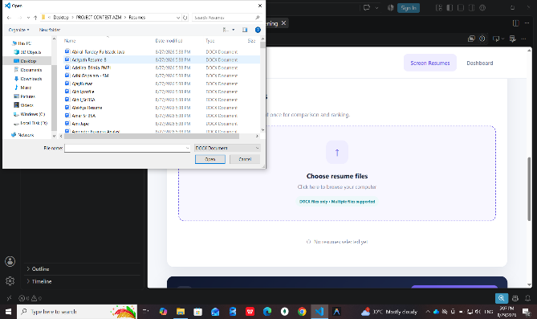
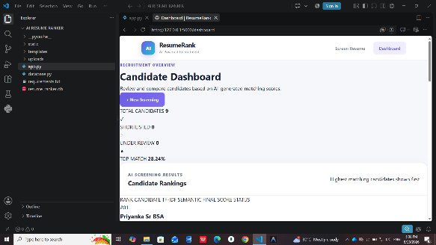
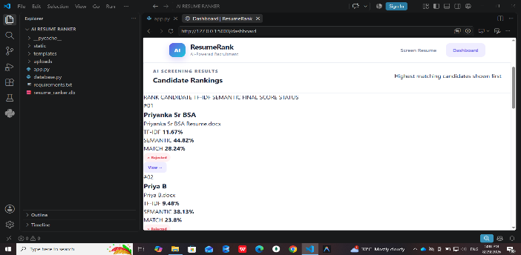
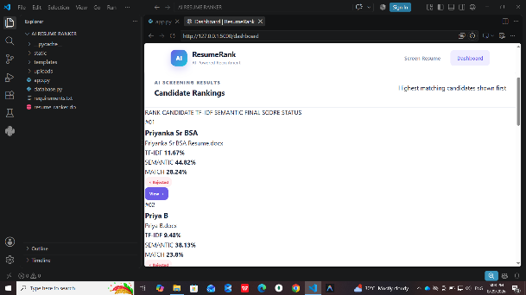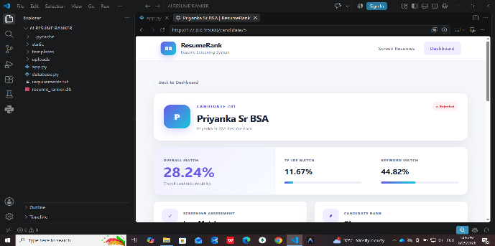

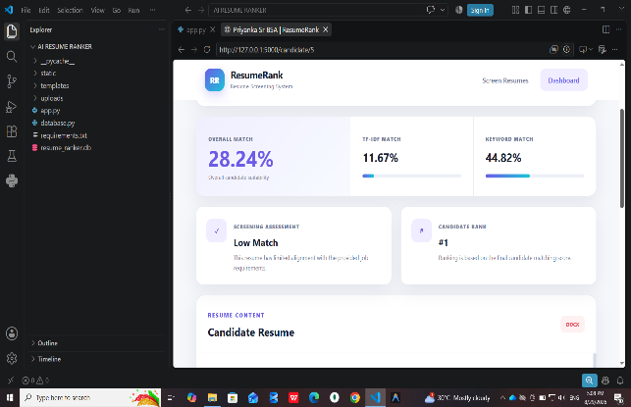
Final Thoughts:
Resume Rank came out of a fairly simple observation: resume screening takes up a lot of time and doesn't always produce consistent results, even with good recruiters doing the work. By combining basic NLP preprocessing, a two-part scoring system, a proper database layer, and an interface built for non-technical users, the project turns an unsorted batch of resumes into a ranked shortlist in a matter of seconds instead of hours.
It's not built to make hiring decisions on its own, and it shouldn't. What it's built to do is handle the repetitive first pass, so the people actually making the decision can spend their time where it counts, getting to know the candidates who are genuinely worth a closer look.

